Michael Murray and Associates Pty Ltd

Public Hearing Report

Reclassification of Community Land
Amendment to Zoning

Tuesday 28 March 2023

Lake Macquarie Council Chambers

Michael Murray & Associates
1154 Clarence Town Road
Seaham NSW 2324

Phone: 0419 638344
Email: mm@mmurray.com.au

Background

A public hearing was conducted in Lake Macquarie City Council Chambers on Tuesday 28 March 2023 to enable members of the community to express, and have recorded, their views on the proposal to reclassify nine parcels of land from Community to Operational land and rezone one as per the table below:

Item No. | Address | Intended outcomes | Proposed changes to the LMLEP
1 | 60-62 Main Road, Boolaroo  Lot 4 and 5 Sec E DP 3494 | Commercially lease the whole of the property. | - Reclassify as operational land.
2 | Part of 27C First Street, Cardiff South, Lot 30 DP 196, south of Ada Street | Dedicate as road. | - Reclassify as operational land.
3 | 27 First Street, Cardiff South, Lot 1 DP 190522 and  27C First Street, Cardiff South, Lot 30 DP 196, north of Ada Street | Close the road, redevelop for residential use and sell to the public. | - Reclassify as operational land.  - Rezone from R2 Low Density Residential to R3 Medium Density Residential.  - Change Height of Buildings Map (HBM) from 8.5m to 10m.  - Change Lot Size Map (LSM) from 450sqm to 900sqm.
4 | 21 Narara Road, Cooranbong  Lots 4, 5, 6 and 7 Section O DP 724 | Sell to the public for residential use. | - Reclassify as operational land.  - Rezone from RE1 Public Recreation to R2 Low Density Residential.  - Add to LSM at 450sqm.
5 | 48 Oakdale Road, Gateshead  Lot 20 DP 1115790 | Commercially lease the whole of the property. | - Reclassify as operational land.
6 | 4a Clare Street, Glendale  Lot 103 DP 553828 | Sell to adjoining owners for residential use. | - Reclassify as operational land.  - Rezone from RE1 Public Recreation to R3 Medium Density Residential.  - Change HBM from 8.5m to 10m.  - Add to LSM at 900sqm.
7 | 62A Graham Street, Glendale  Lot 62 DP 247342 | Redevelop and sell to the public for residential use. | - Reclassify as operational land.  - Rezone from RE1 Public Recreation to R2 Low Density Residential.  - Add to LSM at 450sqm.
8 | 16 Skye Street, Morisset  Lot 1 Section 12 DP 758707 | This is one lot of three lots to be sold together for residential use. This lot is constrained due to an Asset Protection Zone (APZ) and riparian zone required for the development of the other two lots. | - Reclassify as operational land.
9 | 38 Alison Street, Redhead  Lot 50 DP 844457 | Redevelop and sell to the public for residential use. | - Reclassify as operational land.  - Rezone from RE1 Public Recreation to R2 Low Density Residential.  - Add to LSM at 450sqm.
10 | 20 Ruttleys Road, Wyee  Lot 495 DP 755242 | Redevelop and sell to the public for residential use. | - Rezone from RU6 Transition to C4 Environmental Living.  - Change LSM from 200ha to 2ha.

The public hearing had been advertised by Council in the local press in accordance with regulatory requirements.

Attendance

The hearing was convened by Joanne Marshall, Statutory Property Officer for Lake Macquarie City Council with Michael Murray performing the role of independent facilitator.

Also in attendance were Elizabeth Lambert Manager of Property & Business Development and Sara Young Trainee Land Administration Officer.

The Process

The meeting was opened at 6.00pm. Five (5) people attended the hearing, but in all cases, they indicated that they were at the hearing to provide input on item #3, the Cardiff South reclassification. Council had resolved to remove this item from the proposal and therefore the hearing agenda and staff had communicated this decision via email prior to the hearing.

Ms Marshall met individually with each of these people to explain the decision to withdraw this parcel of land from the proposal and therefore the hearing agenda and indicated that if Council decided to pursue the matter in future it would be done so through a new, separate process. She also indicated that they would be kept informed if this was to occur.

There were no community members in attendance to provide input on the reclassification matters included in the proposal.

The meeting was formally closed at 6.45pm.

Conclusion

I am satisfied as the independent facilitator of the hearing that Council provided an appropriate opportunity for members of the community to provide input in relation to the proposed reclassification matters in accordance with the Local Government Act.

The meeting closed at 6:45pm.
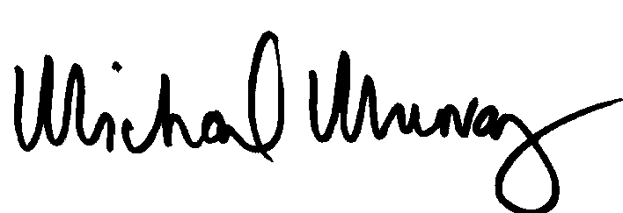

Michael Murray
Managing Director, Michael Murray & Associates
28 March 2023

